Sprint Round Write-Up

Alas, we lost both our games.

Game 1 summary
The first game was played on the relatively small map XXX. This is notable for having a relatively large number of neutral team players.

Game 2 summary

What we did well
Units successfully engaged in combat using kiting strategy

What we did badly
Bug caused our units to explode
Units did not form coherent groups
Units did not kite in coherent groups
Did not seek and destroy zombie spawn points
Archons would get trapped
Should return damaged units to the Archons to get healed

What our opponent did well
Moved their Archons together
Formed a defensive perimeter

What our opponent did badly
Did not balance units between perimeter
Did not move center of gravity

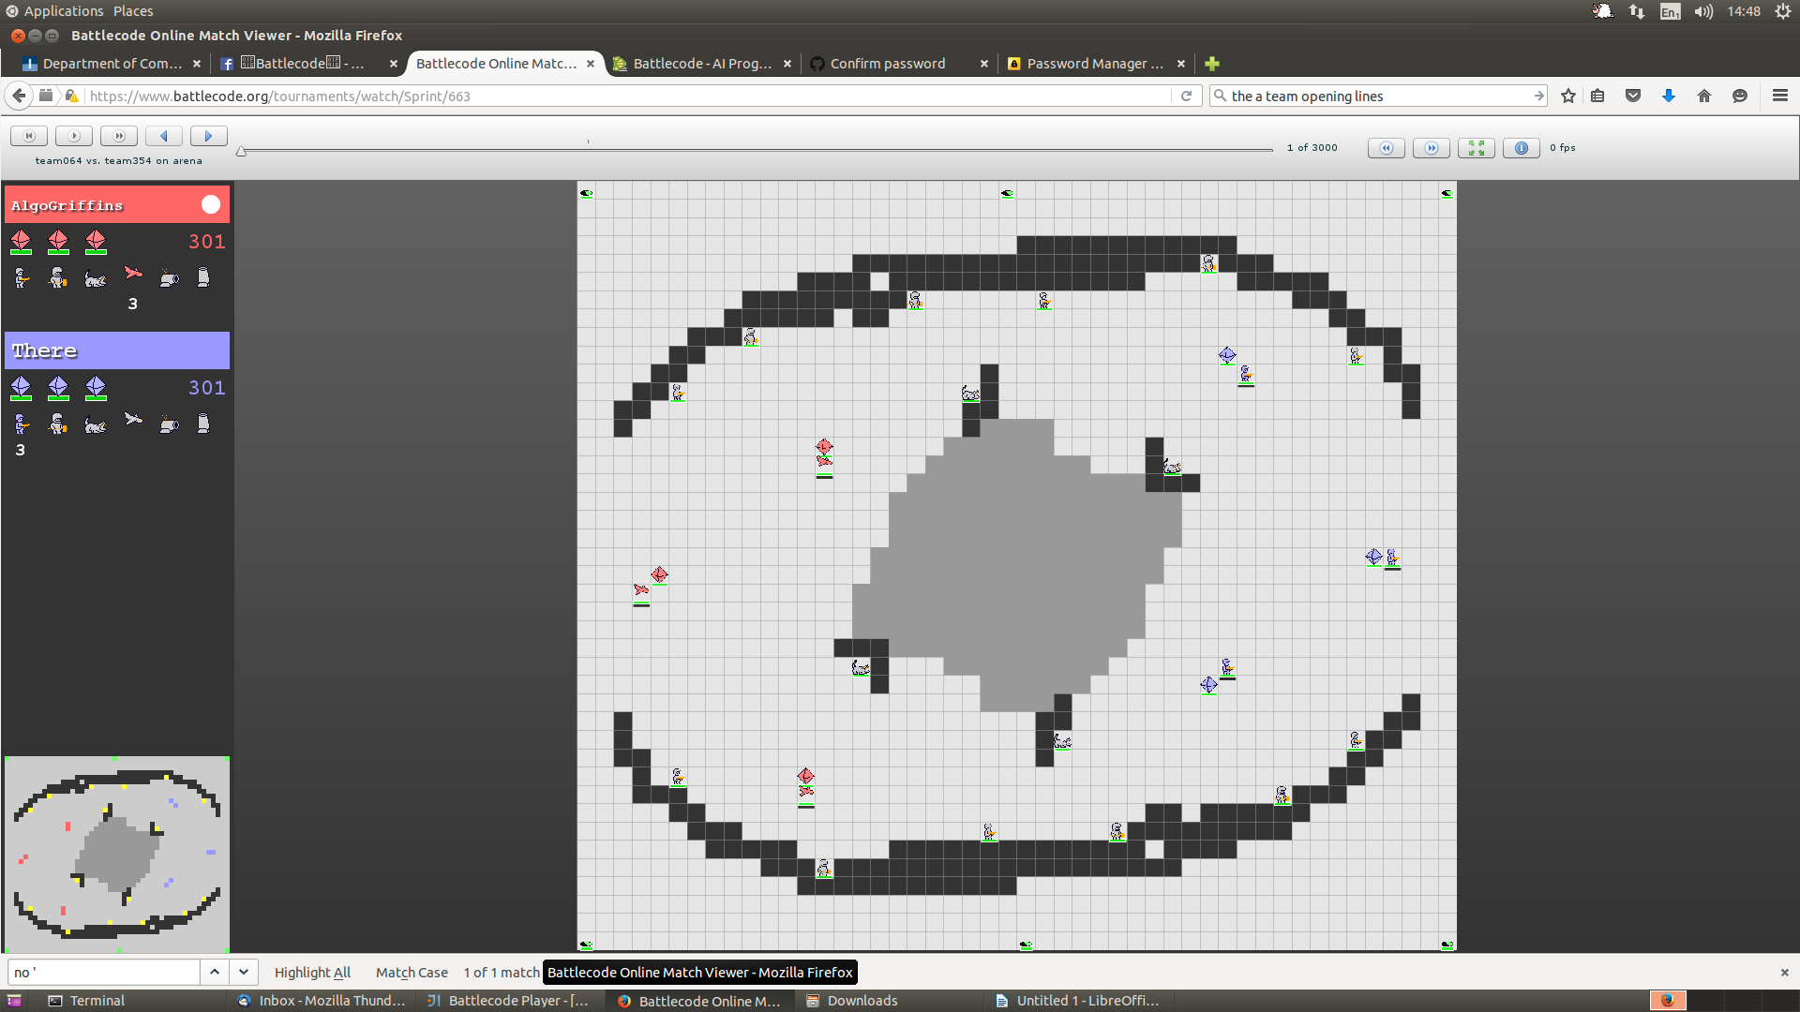
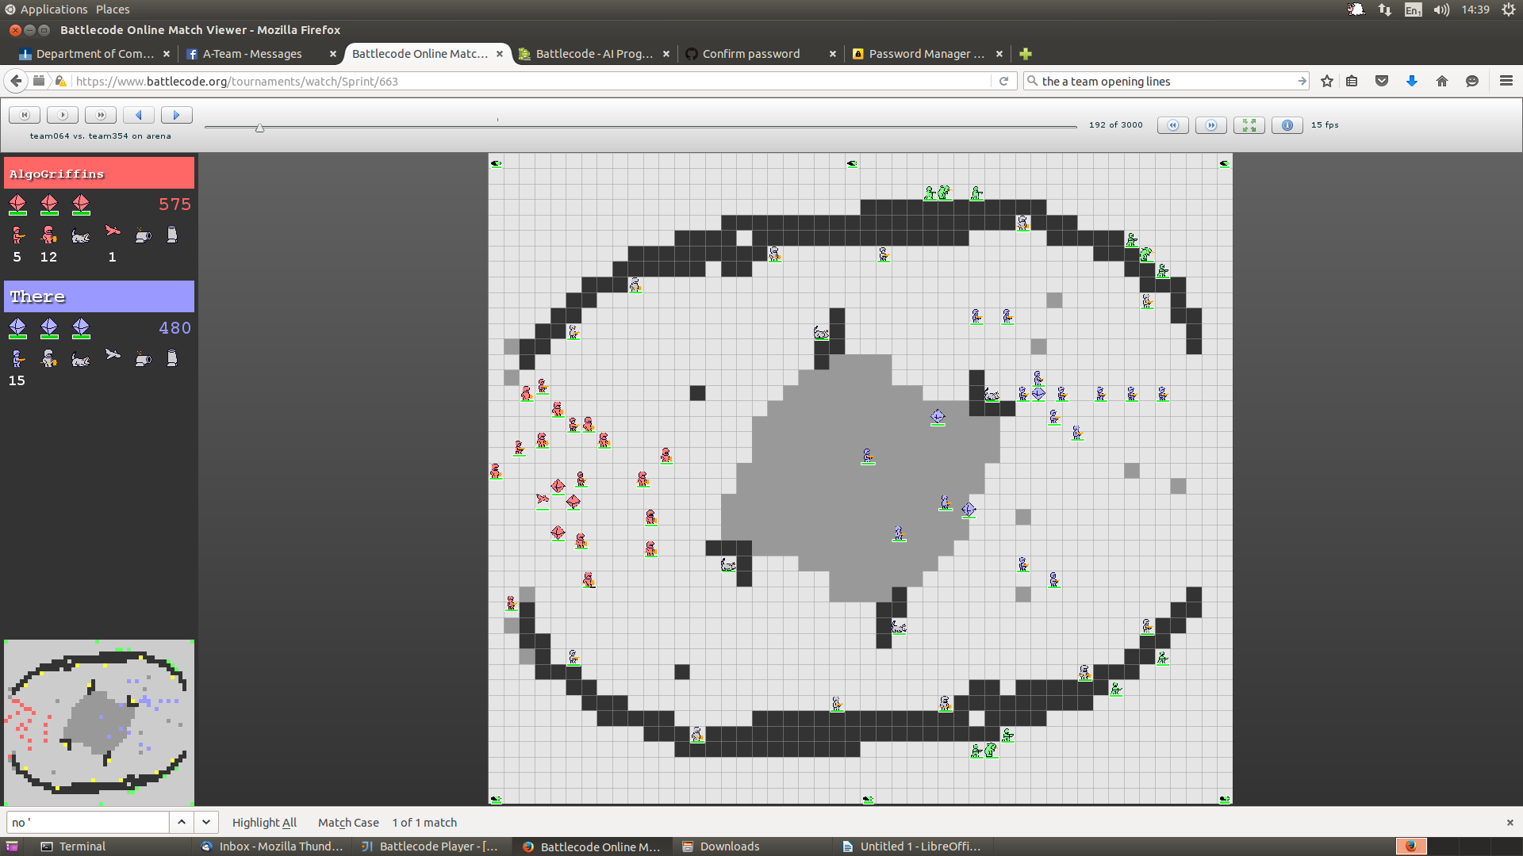

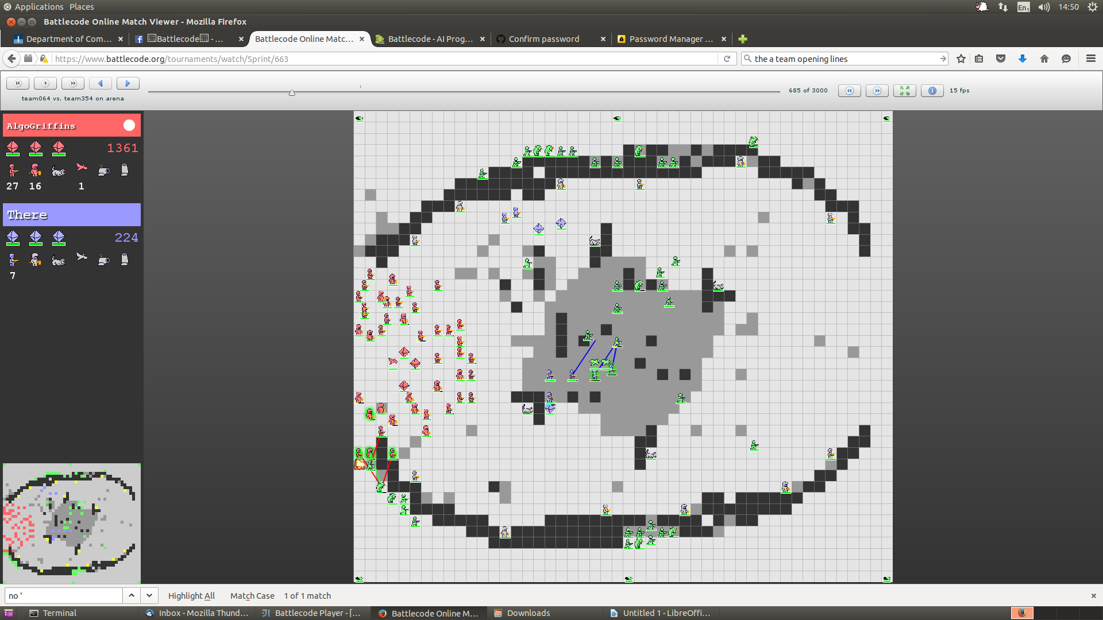

trapped archons
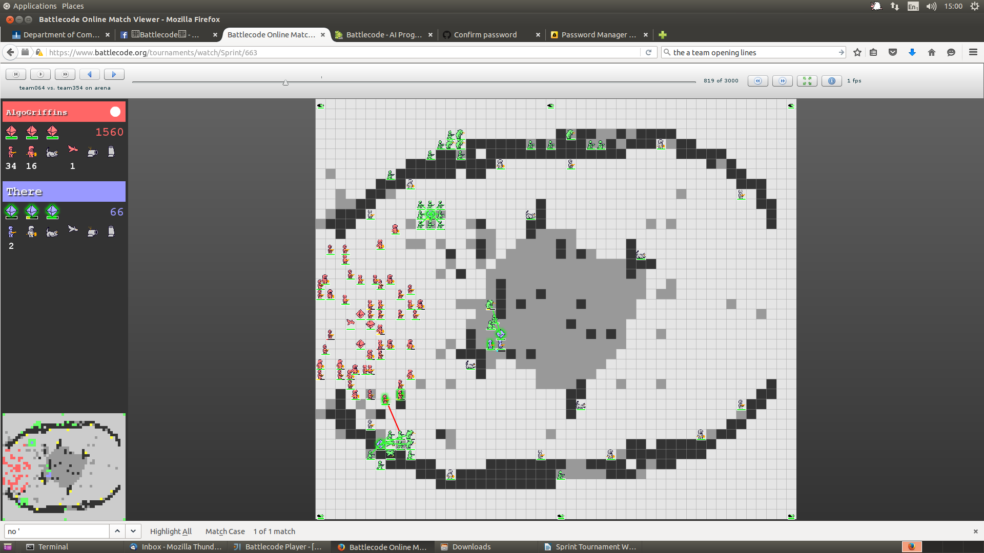

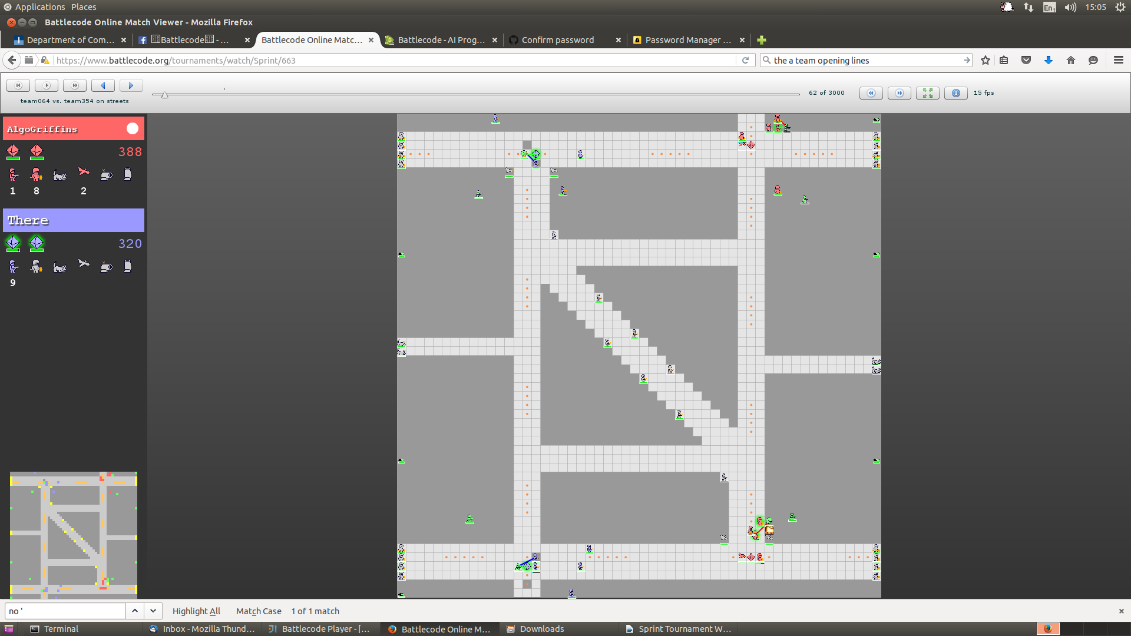
Fleeing Units trapping Archon
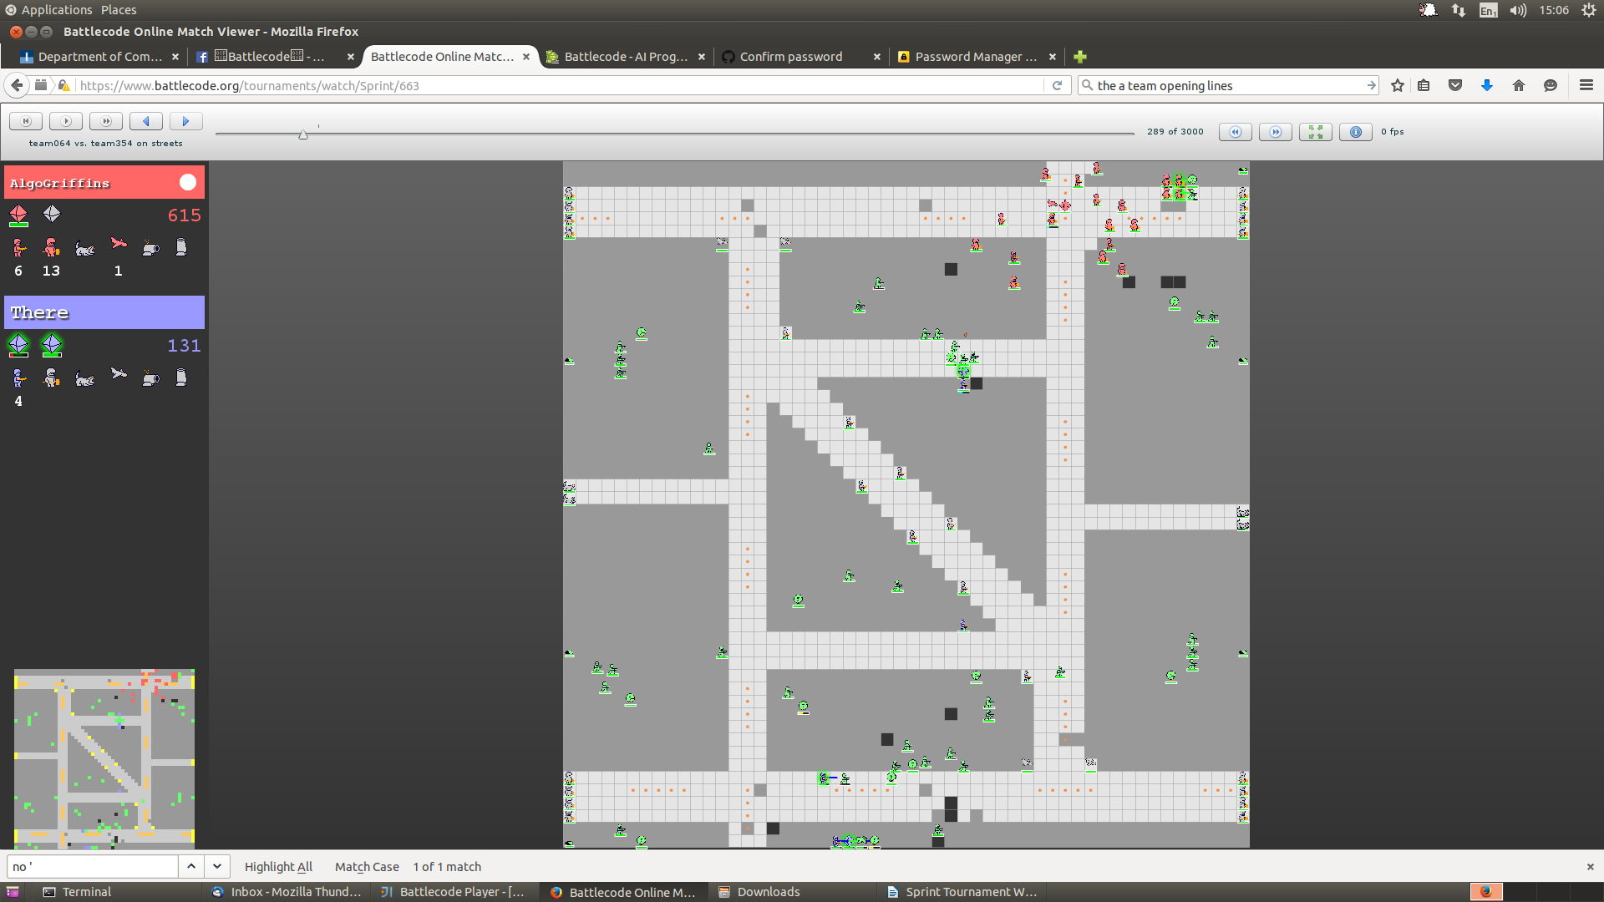

Units did not defend near by Archon in trouble
